Table of Contents

1. Data Digitization of Shiv Yog Farmers 2

2. Advisory Services - Mobile Application 5

3. In Store management 6

4. Market Connect 8

5. Dashboard 10

# Data Digitization of Shiv Yog Farmers

* 1. Collection of group details
     1. Group location
     2. Address
     3. Contact Person
  2. Collection of Farmer Personal details
  3. Land details geo tag the Land Coordinates
  4. Irrigation details
  5. Crop details (previous and current)
  6. Soil report if any
  7. Farmer Card Issuance

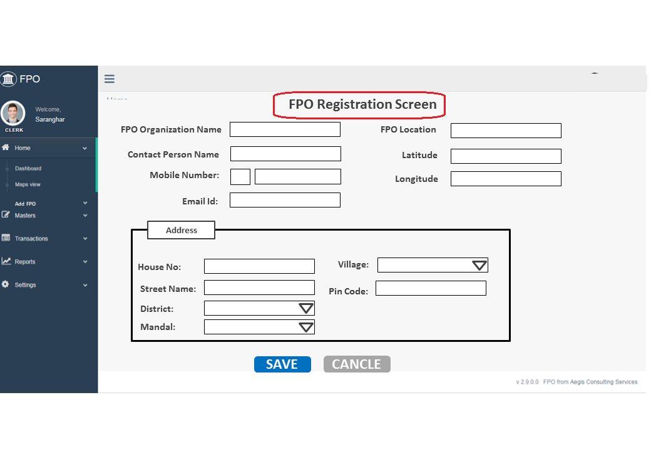

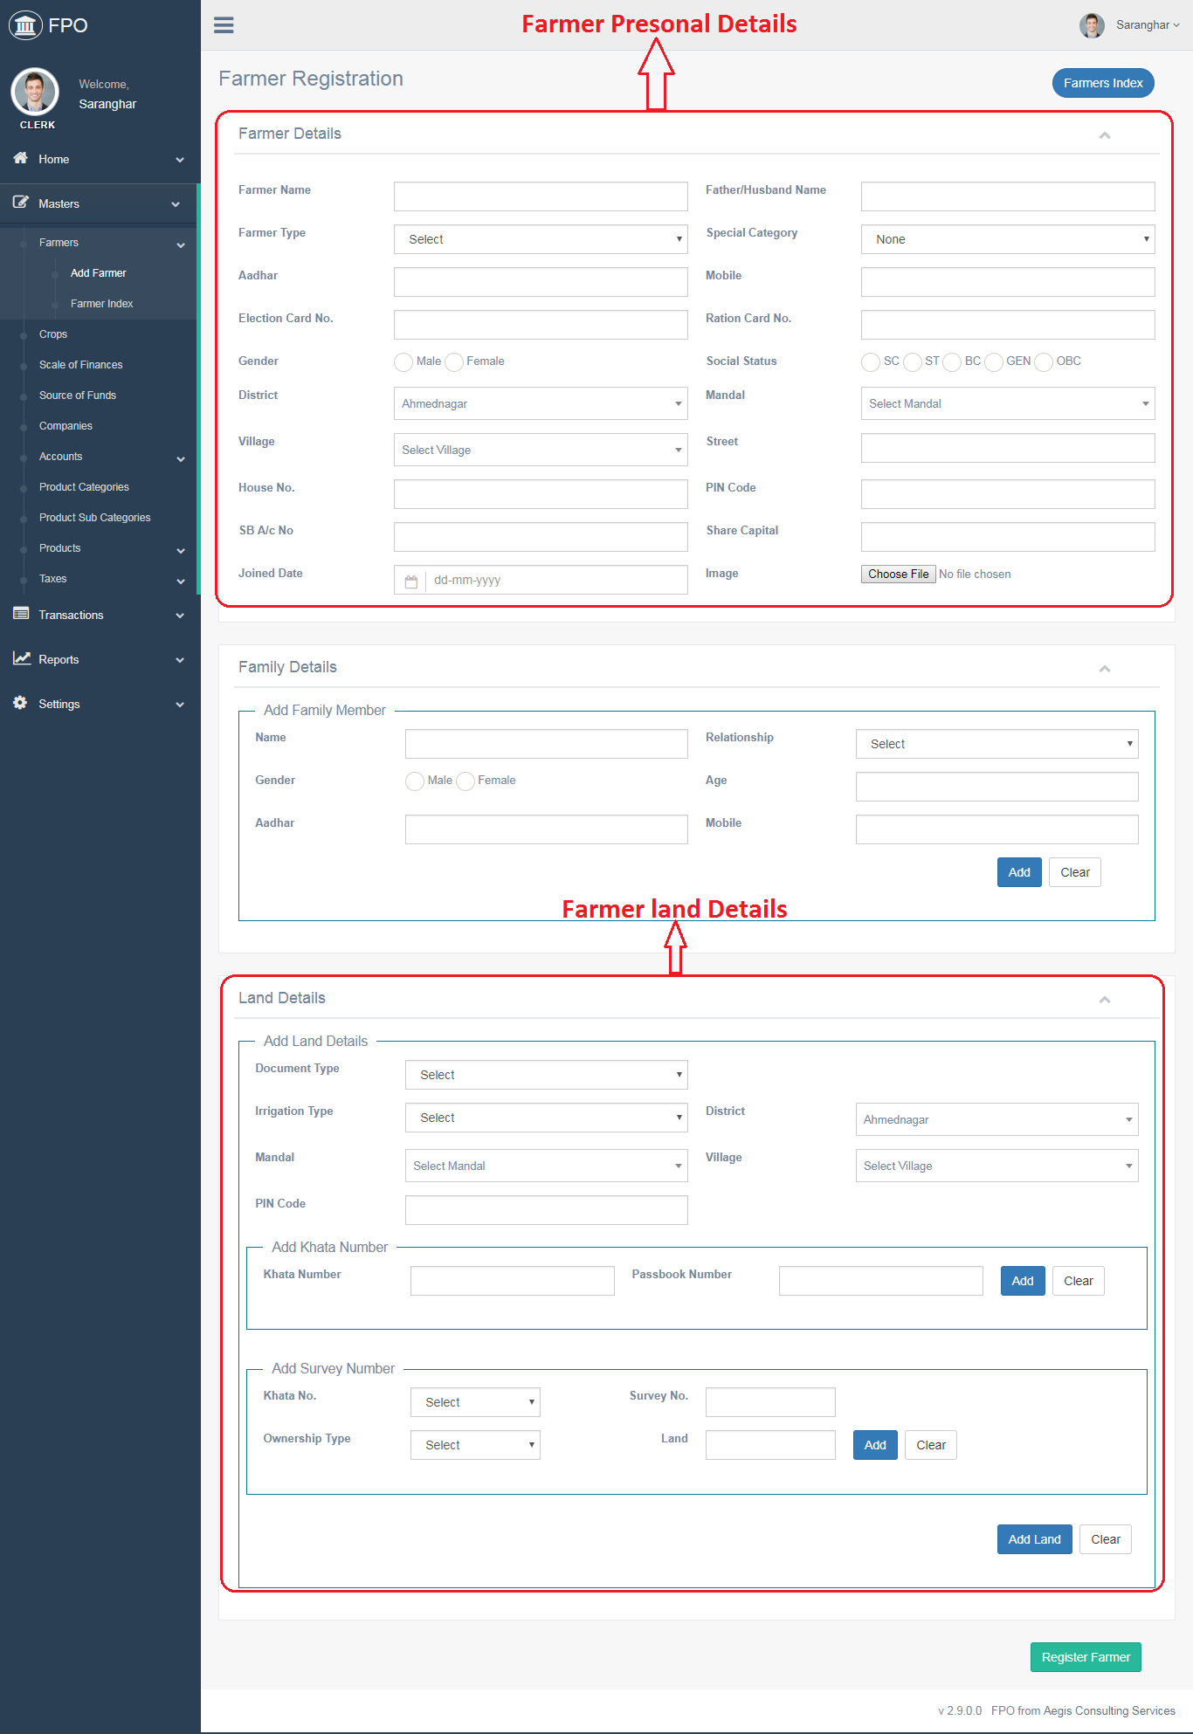

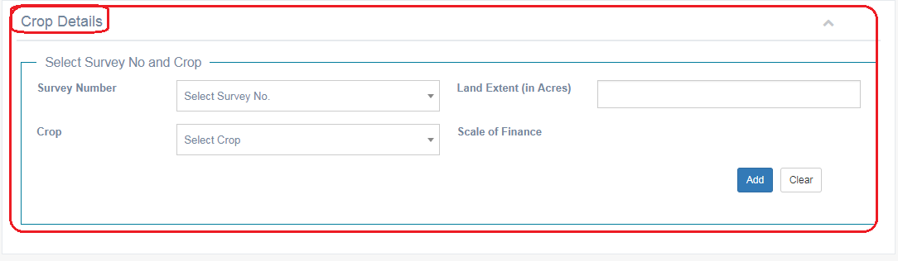

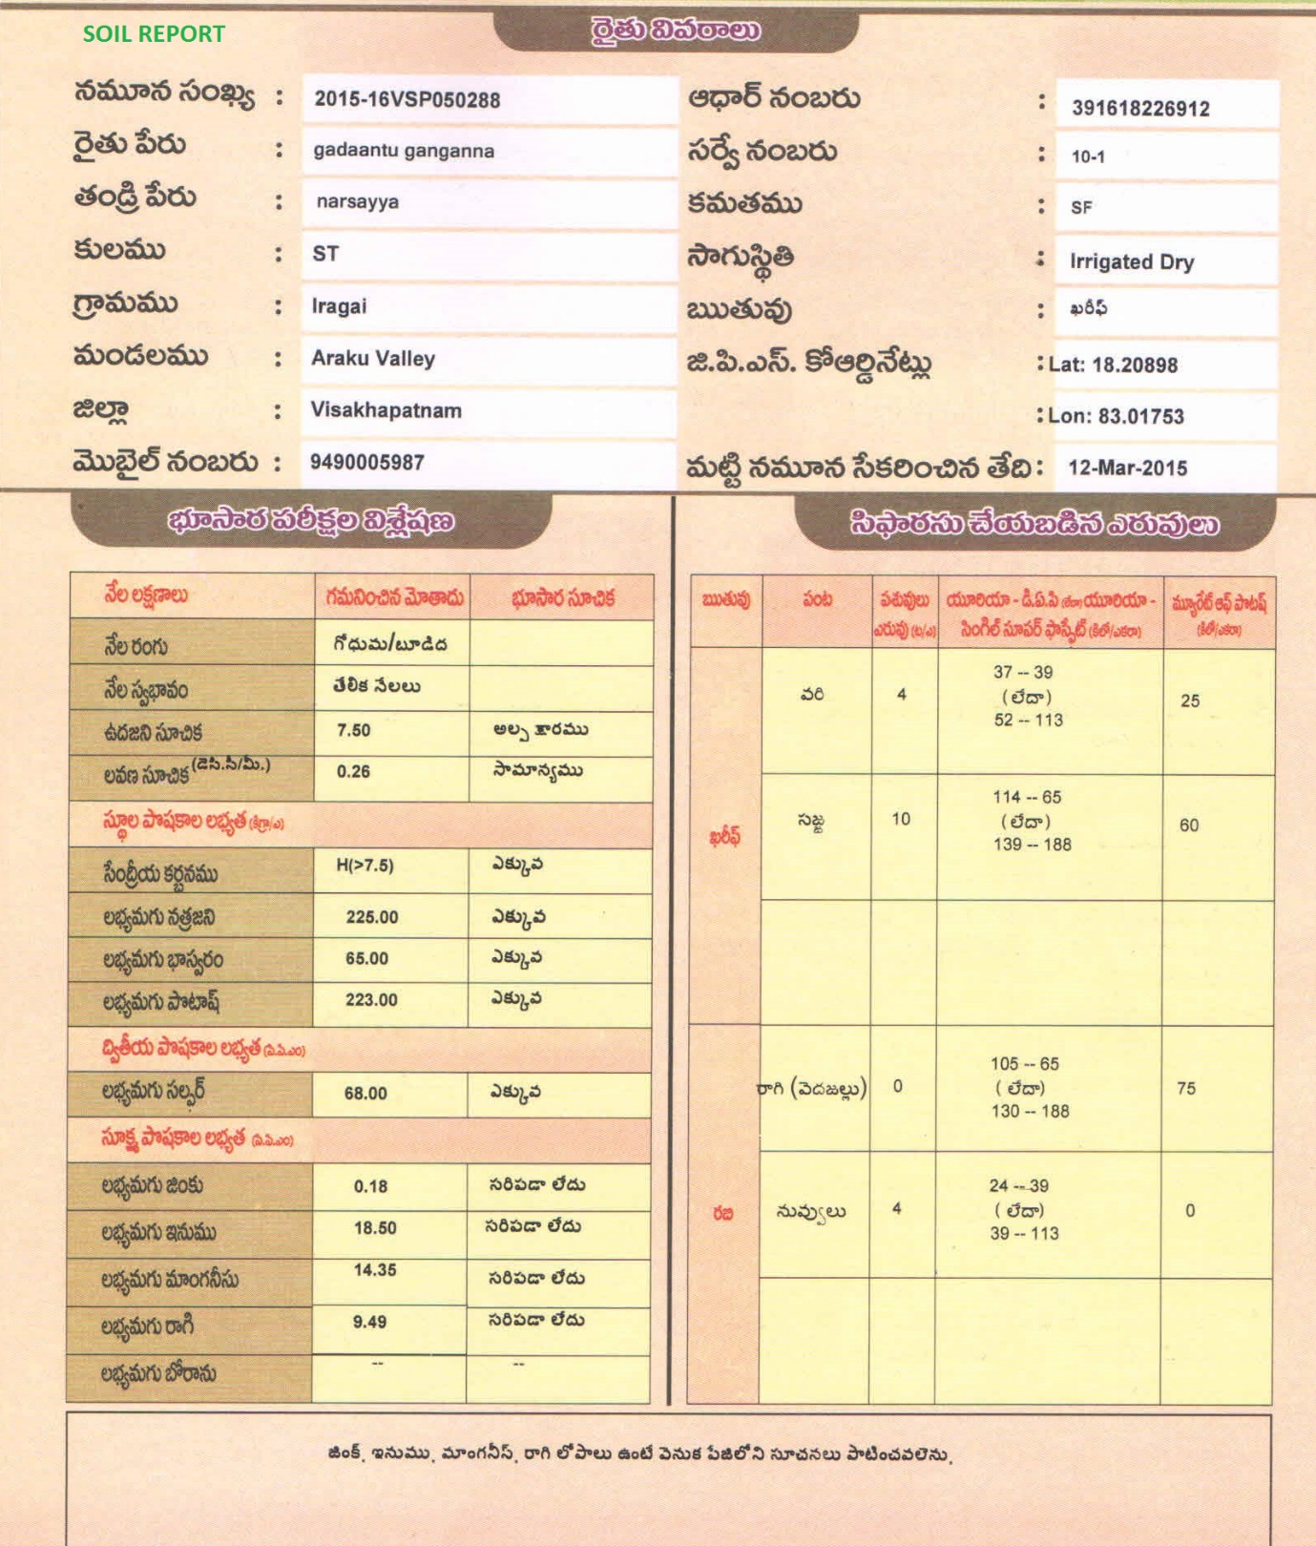

# Advisory Services - Mobile Application

* 1. Messaging System for communication
  2. Transmission of video and audio
  3. Soil sample collection and report entry
  4. Cost of cultivation
     1. Land preparation
     2. Seed procurement
     3. Other expenses
     4. Harvest expenses
     5. Labor expenses
     6. Transportation and miscellaneous charges
     7. Farmer wise cost benefit analysis

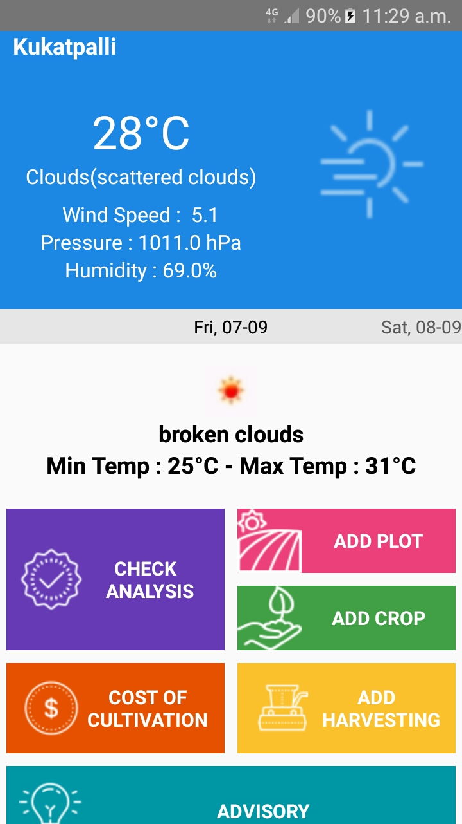

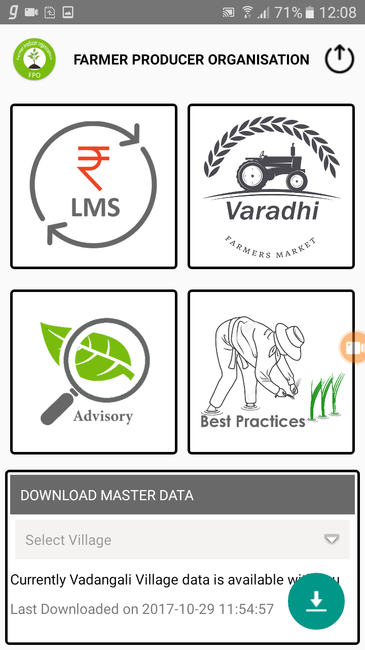

# In Store management

* 1. Shiv yog group Store Management
  2. Complete Store Management
     1. Sale of Products (seeds, etc)
     2. Procurement
     3. Reports
        1. Sale reports
        2. Procurement reports
        3. Payment to Vendors
     4. Accounts Management

1. Soil Lab
   1. Soil Sample details
   2. Results entry
2. Drone Services
   1. Record the video of the field
   2. Crop videos on the field before and after

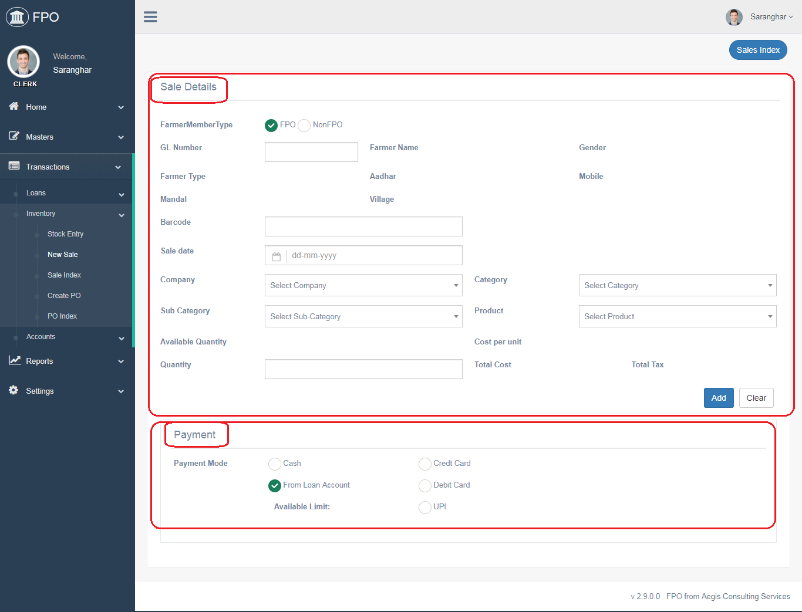

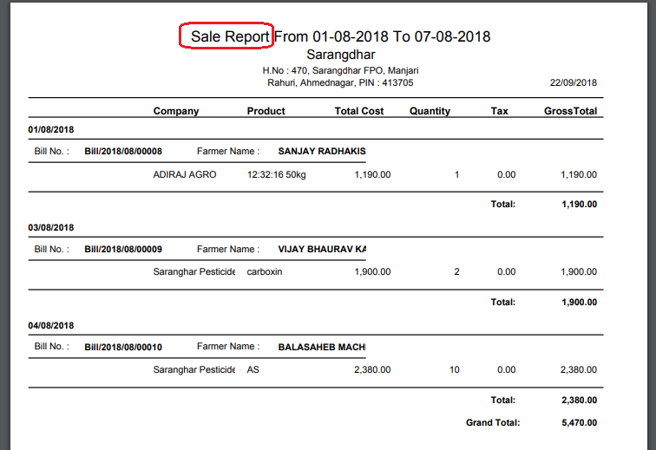

# Market Connect

* 1. Crop Details
     1. Estimated Produce
     2. Approximate Harvest date
     3. Produce pick up
  2. Registration of buyers
  3. Order booking
  4. Collection of produce
  5. Sale report to farmer

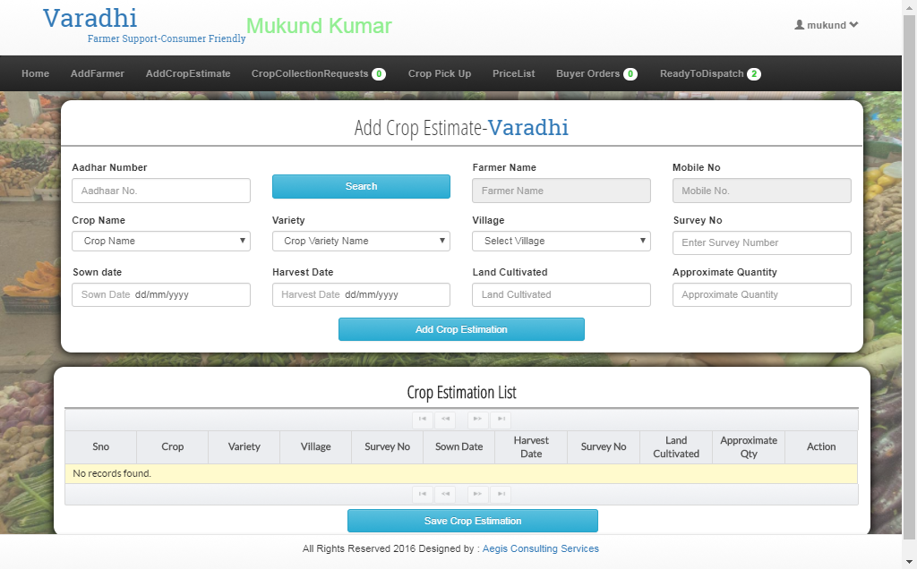

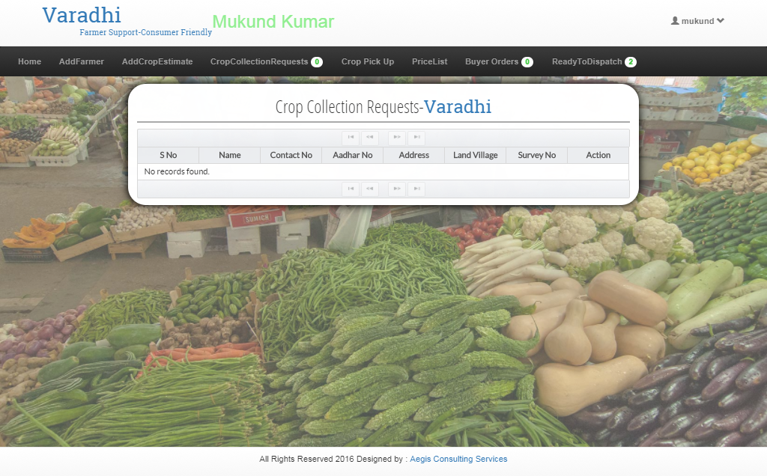

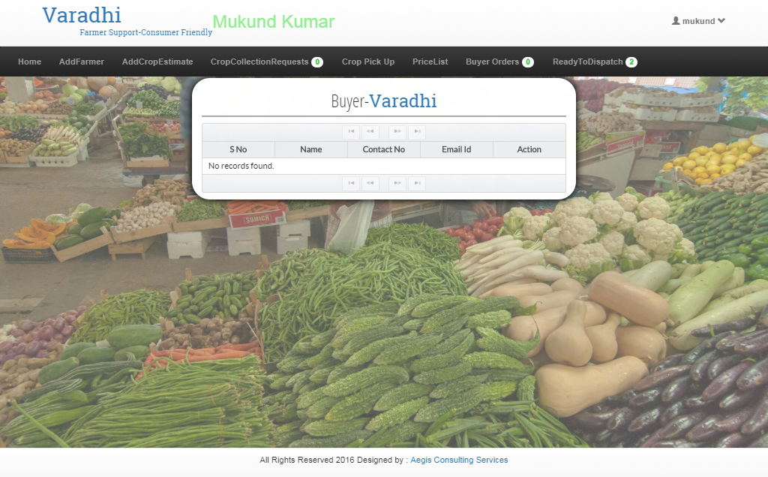

# Dashboard

* 1. User
     1. Each group will have a dashboard
     2. No. of farmers
     3. Crop wise data
     4. Area wise
     5. Soil nutrition improvement data
     6. Available Crop, Order and sale report
  2. Admin
     1. Report on individual Shivyog group
     2. Crop wise, group wise comparison
     3. Integrate farmer and land details with google
     4. State wise, Area wise, group wise data visualization
     5. Data Analysis
  3. Farmer
     1. Soil sample report and comparison
     2. Crop wise data
     3. Sale wise data